Jeff’s Jots
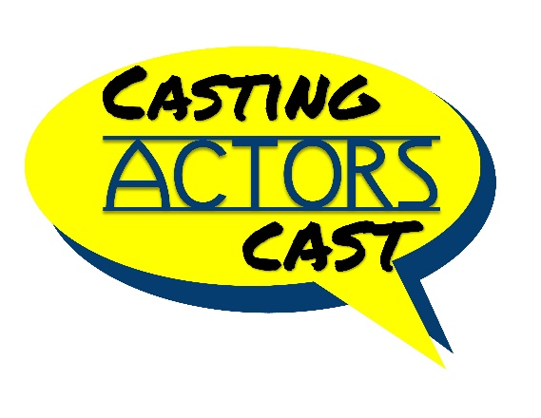

Jeffrey Dreisbach
Self-Tape Setup Audit Worksheet
Why This Matters
Your self-tape setup sends a message before you ever say a word.
Casting professionals are looking for clarity, intention, and professionalism—and they notice the little things. Use this worksheet to assess your setup and ensure you're putting your best foot forward.
✅ Visual Setup
Is your background neutral, uncluttered, and distraction-free?
Are you asymmetrical in the frame, with a minimal amount of headroom?
Is your camera at eye level, not too high or low?
Are you well-lit from the front, with no harsh shadows or flickering light?
Is your eye line appropriate to the scene and consistent throughout?

✅ Sound Setup
Is your voice clear and at a consistent volume?
Are there any distracting background noises (fans, pets, traffic)?
Have you tested the audio playback before recording your final takes?

✅ Performance Space
Do you have enough space to move naturally within the frame?
Can you maintain energy and focus in the space you’ve chosen?
Is your backdrop free from elements that pull focus from your performance?

✅ Final Touches
Have you done a test recording to check lighting, sound, and framing?
- Does your setup communicate professionalism and intention?
Do you feel confident and focused with yourself and the other character(s) placement in the scene?
Final Reminder
A great self-tape doesn’t require expensive equipment—it requires intentional choices. Your setup reflects your preparation, presence, and pride in your work.

